Project Design Phase–II
Technology Stack (Architecture & Stack)
Date | 15 February 2026
Team ID | LTVIP2026TMIDS78015
Project Name | Importing & Securing Data in ServiceNow
Maximum Marks | 4 Marks

Technical Architecture
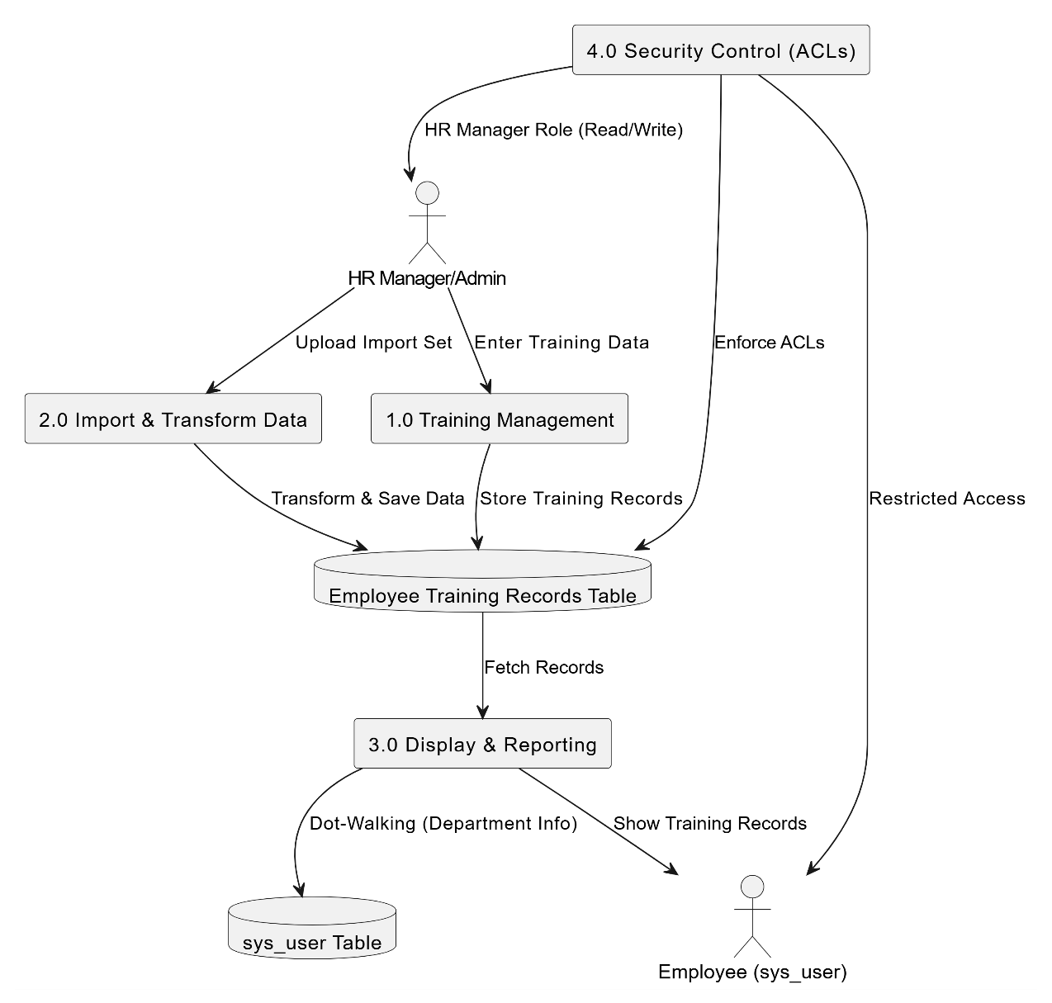
The Importing & Securing Data in ServiceNow follows a cloud-based ServiceNow architecture, integrating user interaction, application logic, database storage, and security mechanisms within a unified platform.

Table-1 : Components & Technologies
S.No | Component | Description | Technology
1 | User Interface | Interface used by HR Managers and administrators to manage employee training records. | ServiceNow Classic UI
2 | Application Logic-1 | Data import and transformation of employee training records. | Import Sets & Transform Maps
3 | Application Logic-2 | Business rules for managing employee training information. | ServiceNow Server-side Scripts
4 | Application Logic-3 | Retrieval of employee department details using relationships. | Reference Fields & Dot-Walking
5 | Database | Storage of employee training and user information. | ServiceNow Cloud Database
6 | Access Control Layer | Secure access management for training records. | ACL (Access Control Rules)
7 | Infrastructure | Application development and deployment environment. | ServiceNow Studio & Developer Instance

Table-2 : Application Characteristics
S.No | Characteristics | Description | Technology
1 | Platform Framework | Built using ServiceNow low-code development environment. | ServiceNow Platform
2 | Security Implementations | Role-based access control for sensitive employee training data. | Roles & ACLs
3 | Scalable Architecture | Cloud-based architecture separating presentation, logic, and data layers. | ServiceNow Multi-tier Architecture
4 | Availability | Accessible through web browser anytime for authorized users. | ServiceNow Cloud Infrastructure
5 | Performance | Fast retrieval and display of training records and department information. | Optimized ServiceNow Tables & Queries

